Biotechnet Conference Report:
TEDD Events 2025
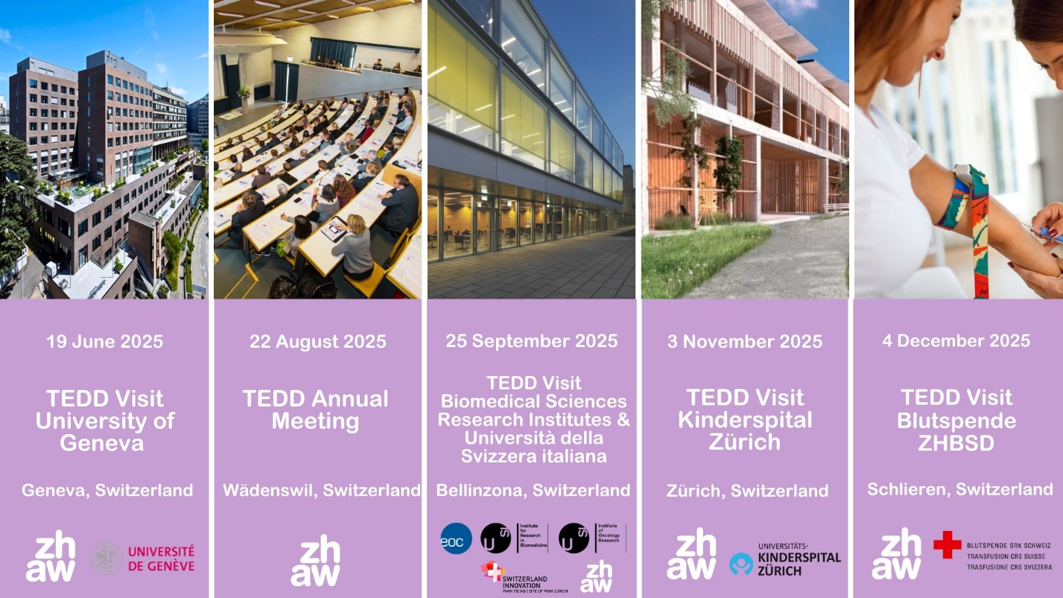

TEDD Visit: TEO Tissue Engineering and Organoid Technology Platform
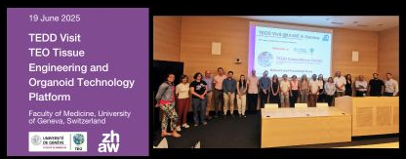
 | Quick Facts
 | 19 June 2025, Faculté de Médecine, Centre Médical Universitaire (CMU), 1 rue Michel Servet, 1206 Geneva, Switzerland
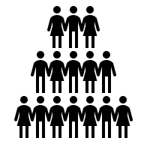 | 20 Participants  Academic, SMEs, startups, clinical
 | Talks by scientists, Networking Lunch, Lab Tours
 | Organized by: Competence Centre TEDD, Faculty of Medicine, University of Geneva
 | Takeaway
 | In an effort to fully leverage the potential of tissue engineering and organoid-based technologies while promoting innovative strategies, the Faculty of Medicine of the University of Geneva established in Q4 2024 the Tissue Engineering & Organoid (TEO) Technology at the Centre Médical Universitaire (CMU). This platform serves as a hub for translational bioengineering expertise, offering consulting services, research and development, and instrumental support for fundamental research initiatives.  With a strong focus on clinical impact, TEO bridges academic research at UniGE with clinical innovation at the Geneva University Hospitals (HUG), working in close partnership with the Laboratories of Cell Therapies and Transplantation (LTC). Together, they develop and accelerate new technologies toward clinical application.  TEO Technology Platform has the mission to:  Provide dedicated space and tailored services for organoid-based research and technological innovation.  Support the design of optimized preclinical testing strategies.  Facilitate and accelerate the clinical translation of novel biomedical technologies and therapies.
Session Highlights
Scientific talks
- Ekaterine Berishvili, Laboratory of Tissue Engineering and Organ Regeneration, UniGE
- NeuroNA Human Cellular Neuroscience Platform: bespoke high-end services, Dr. Théo Ribierre, NeuroNA Human Cellular Neuroscience Platform (HCNP)
- GMP Cell Therapy Lab at Geneva University Hospital: bridging translational research, Dr Mathieu Armanet, Clinical Cell Therapy (LTCC), Geneva University Hospitals
- Functional assessements of human cardioids to model heart development, Dr Marisa Jaconi, Dept. Basic Neurosciences, UniGE
Lab Tours
- TEO Platform
- Research groups
- GMP labs at HUG

TEDD Annual Meeting 2025: Advancing Biomedical Research with NAMs (New Approach Methodologies): Innovations and Applications in Switzerland
Quick Facts
22 August 2025, ZHAW Campus Grüental, Wädenswil, Switzerland
90 Participants
Academic, SMEs, startups, clinical
Talks by scientists, Networking Lunch & Apéro, Exhibition
Organized by: Competence Centre TEDD, ZHAW
Takeaway
New Approach Methodologies (NAMs) are transforming the landscape of biomedical research by offering innovative, ethical, and more human-relevant alternatives to traditional animal testing. These methods include advanced in vitro systems, organ-on-chip technologies, computational models, and the use of human-derived data. In Switzerland, a country known for its excellence in life sciences and precision medicine, the integration of NAMs is gaining momentum across academia, industry, and regulatory bodies. With strong institutional support and a commitment to the 3Rs (Replacement, Reduction, and Refinement of animal use), Swiss researchers are pioneering applications that improve translational relevance and efficiency in biomedical studies. As the global demand for more predictive and ethically responsible research methods grows, NAMs offer a critical pathway for scientific innovation and patient-centred progress. This conference will highlight the latest advancements, regulatory strategies, and collaborative opportunities shaping the future of biomedical research in Switzerland.
Session Highlights
Scientific talks
- Precision Oncology: The Journey from Patient Bedside to Research Bench and Back, Prof. Marianna Kruithof - de Julio, Translational Organoid Models, University of Bern
- Latest developments in supporting translational research with bioengineered in vitro models, Dr Gaspard Pardon, AGORA Center Bioengineering & Organoids Technology Platform
- How to establish permanent serum-free cell culture – a short review and guideline, Dr. Beat Thalmann, Scinora
- Long-term culture system for primary human epithelial cells enabling clonal expansion from single cells, Dr Elias Imahorn, CELLnTEC
- Biohybrid Musculoskeletal Robotics, Prof. Robert Katzschmann, Soft Robotics Lab, ETH Zurich
- High throughput retinal organoids for therapy development, Dr. Magdalena Renner, Human Organoid Platform, Institute of Molecular and Clinical Ophthalmology
- Filamented Light (FLight) Bioprinting for Rapid and Tunable Matrix Replication in Engineered Tissue Models, Dr Hao Liu, Lumios
Exhibition
- 3R Competence Centre
- Agilent Technologies Schweiz AG
- Bachem
- Bio-Techne
- Bucher
- CELLnTEC
- Chemie Brunschwig
- Milian
- Scinora GmbH
- Sino Biological Europe GmbH
- STEMCELL Technologies
- Zeiss AG

TEDD Visit: Biomedical Sciences Research Institutes & Università della Svizzera italiana
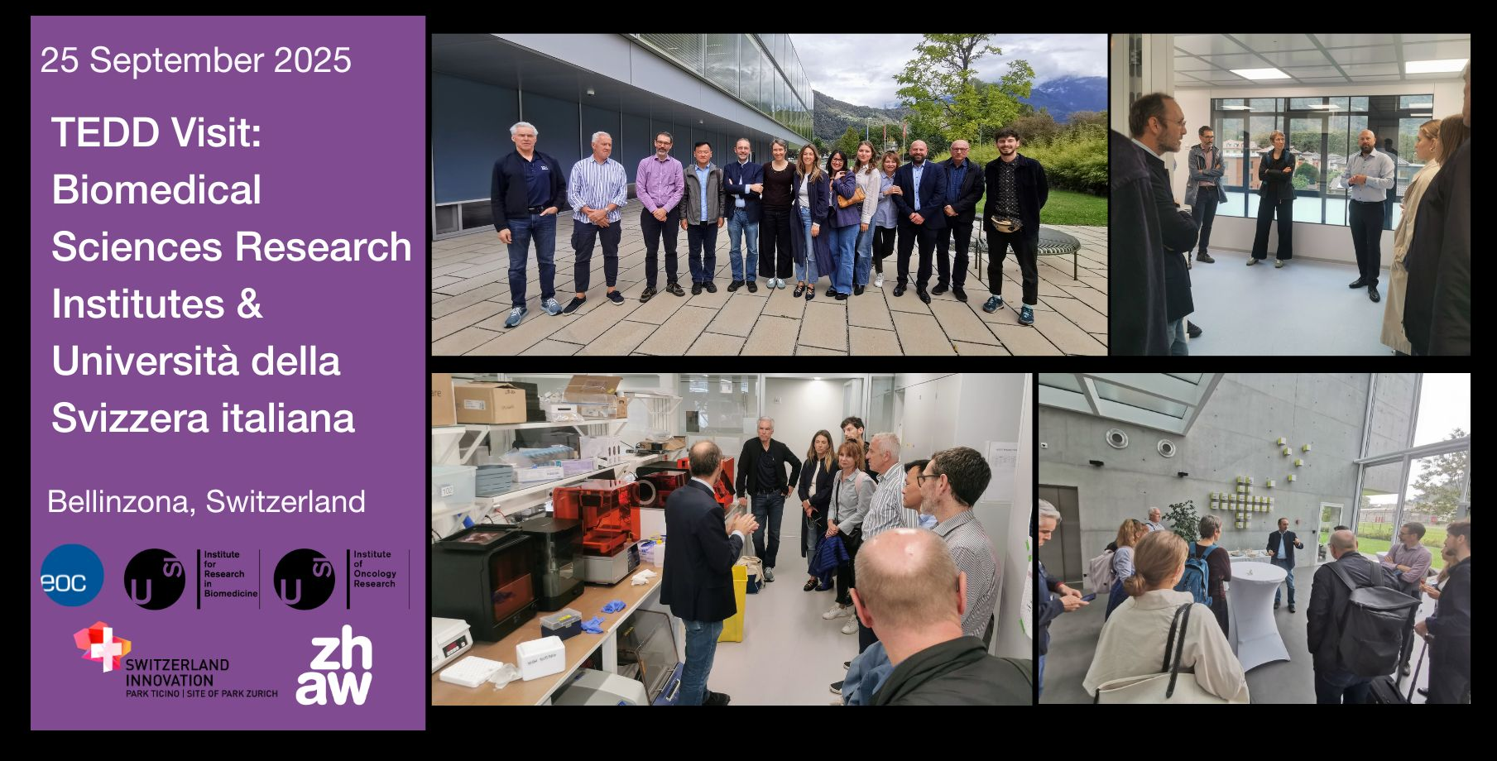
Quick Facts
25 September 2025, Via Francesco Chiesa 5, 6500 Bellinzona, Switzerland
16 Participants
Academic, SMEs, startups, clinical
Talks by scientists, Networking Lunch, Lab Tours
Organized by: Competence Centre TEDD, Institute for Translational Research (IRT EOC-USI), Institute for Research in Biomedicine (IRB), Institute of Oncology Research (IOR)
Takeaway
The Bellinzona Institutes of Science (Bios+) building is a multidisciplinary research hub in Bellinzona that brings together the Institute for Research in Biomedicine (IRB), the Institute of Oncology Research (IOR), the Institute for Translational Research USI-EOC (IRT), all intertwined with Università della Svizzera italiana.

Bios+ provides shared facilities, coordinated governance, and a collaborative campus that accelerates research. IRT and the hospital network contribute to patient‑centered translational solutions and clinical expertise. IOR concentrates on cancer research and translational oncology, driving projects from molecular studies to clinical applications. IRB focuses on human immunology in health and disease.

Within this multidisciplinary environment, some labs specifically develop and rely on 3D in vitro human model systems, organoids and 3R methodologies to advance research. Taken together, these three entities create thus an integrated ecosystem that supports technology platforms, interdisciplinary projects, and partnerships with universities and industries. Bios+ aims at advance biomedical research by offering tailored services, training, and infrastructure to researchers and clinicians with the ultimate goal to benefit patients.

Session Highlights
- Biofabrication, Prof. Matteo Moretti, Institute for Translational Research USI-EOC (IRT)
- Brain Organoids, Prof. Arianna Baggiolini, Institute of Oncology Research (IOR)
- In vitro vs in vivo Models, Prof. Santiago F. González, Institute for Research in Biomedicine (IRB)
- Swiss Innovation Park Ticino-Life Science Competence Center (CCLS)
Lab Tours
- Swiss Innovation Park Ticino-Life Science Competence Center (CCLS)
- Institute for Translational Research (IRT EOC-USI)
- Institute for Research in Biomedicine (IRB)
- Institute of Oncology Research (IOR)

TEDD Visit: Research & Education at University Children’s Hospital Zurich (KISPI)
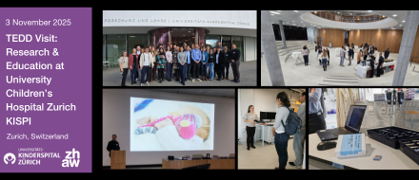
Quick Facts
3 November 2025, Forschung & Lehre, Universitäts-Kinderspital Zürich, August-Forel-Strasse 51, 8008 Zurich, Switzerland
40 Participants
Academic, SMEs, startups, clinical, international
Talks by Scientists, Lab Tour
Organized by: Competence Centre TEDD, University Hospital Zurich
Takeaway
At the University Children’s Hospital Zurich (KISPI), the fight against childhood cancer brings together some of the most dedicated doctors and researchers in Europe. Within the hospital’s Oncology Department, young patients and their families receive care that combines the latest scientific advances with compassion and support. Teams of pediatric oncologists, neurosurgeons, nurses, and psychologists work side by side, ensuring that every child facing cancer is treated not only with medicines and therapies, but also with understanding and hope.

Among the many conditions treated at KISPI, a particular focus is placed on brain tumors such as diffuse midline glioma (DMG), also known as DIPG. These tumors are among the most challenging in pediatric oncology, and for decades little progress had been made in improving outcomes. To change this reality, KISPI established a dedicated DIPG/DMG Center of Expertise. One of the most promising initiatives led from Zurich is called DMG-ACT, which stands for Diffuse Midline Glioma – Adaptive Combinatorial Therapy. This international effort, driven by collaboration across many hospitals and research teams worldwide, aims to give children diagnosed with DMG access to innovative therapies much faster. A key part of KISPI research is drug screening, where relevant medicines are tested against tumor cells to identify promising candidates. Equally important, is the development of advanced cell cultures, miniature tumor models grown in the laboratory, which allow researchers to study how these cancers behave and to predict how children might respond to new treatments.

The hope is simple but powerful: that by working together, and by investing in science as much as in care, we can finally change the story for children and families facing this devastating disease.
Session Highlights
Scientific talks
- Modelling drug response in pediatric diffuse midline glioma from multi-omics characterization, Prof. Sarah C. Brüningk
- Engineering and controlling biohybrid and biomimetic microrobots for magnetically enhanced drug delivery, Prof. Simone Schürle-Finke
- Recapitulating the BBB in vitro to test drug penetration and efficacy, Dr. Mario M. Modena
- Ultrasound-Triggered Drug Release Dynamics for Neural Circuit Manipulation, Dr. Gizem Aydemir
Lab Tours
- KISPI Research building

TEDD Visit: Blutspendedienst Zürich
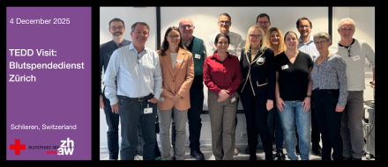
Quick Facts
4 December 2025, Blutspende SRK Zürich, Dienstleistungszentrum, Rütistrasse 19, 8952 Schlieren, Switzerland
10 Participants
Academic, SMEs, startups, clinical, international
Talks by Scientists, Lab Tour
Organized by: Competence Centre TEDD, Blood Transfusion Service, Swiss Red Cross, Zurich
Takeaway
Founded in 1949, the Blood Transfusion Service, Swiss Red Cross, Zurich began supplying blood to Zurich hospitals from a small facility on Gassnerallee. In the early 1950s the Federal Council charged the Swiss Red Cross with organizing a cost-covering national blood donation service based on voluntary, unpaid donations, a mandate the Foundation has upheld ever since and continuously developed.

Today the Blood Transfusion Service, Swiss Red Cross, Zurich employs about 220 people at sites in Zurich, Schlieren, Winterthur, Lachen and Uster and processes around 50,000 donations annually, with strong focus on donor health and patient safety. The organization is now a high‑tech transfusion‑medicine provider, research leader and specialist in rare blood types, and — together with partners in Graubünden, Eastern and Central Switzerland — supplies roughly 40% of the Swiss population.
Session Highlights
Scientific talks
- Buy Platelet Lysate now (hPL), Prof. Dimitrios Tsakiris, Head of Medical Department
- Serum Eye Drops - a new aspect in hemotherapy, Prof. Birgit Gathof, Head of Research & Development
- Insights into blood group diagnostis, Dr. Stefan Meyer, Head of Genetics Departement
- Site-Tour: Blood Collection Center Limmattal, Screening & Immunohematology-Labs, Production, Blood bank, By individual department heads

